**Activity Diagram Exercise**

1. The following activity diagram depicts the **preparation of a meal.**

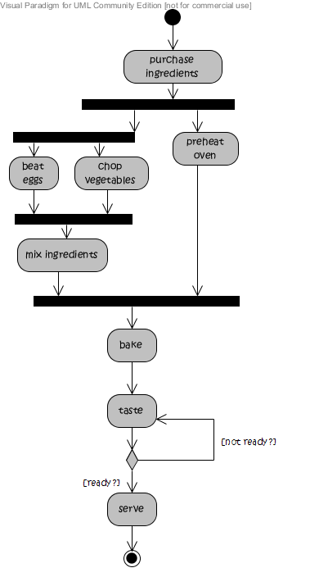

Do the following statements match the above diagram?

|  |  |  |
| --- | --- | --- |
| Matches | Does not match |  |
| 🞏 | 🞏 | 1. preheat oven has to happen prior to mix ingredients. |
| 🞏 | 🞏 | 1. mix ingredients happens as soon as chop vegetables is finished. |
| 🞏 | 🞏 | 1. beat eggs and chop vegetables have to be finished at the same time. |
| 🞏 | 🞏 | 1. taste directly has to follow serve. |

1. The following diagram depicts an activity diagram for **GPS navigation use.**

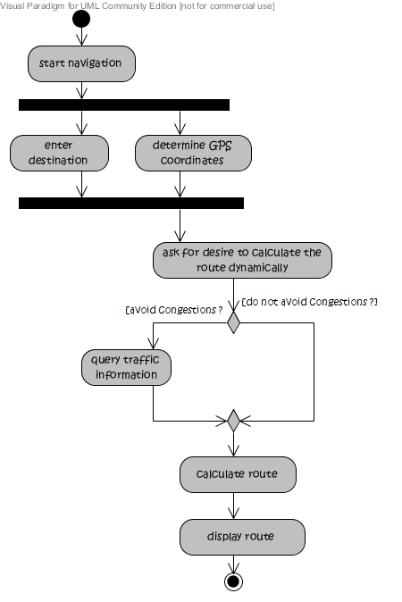

State for each of the following statements whether they are true or false.

|  |  |  |
| --- | --- | --- |
| True | False |  |
| 🞏 | 🞏 | 1. A route can be calculated without querying traffic information |
| 🞏 | 🞏 | 1. A route can be calculated after querying traffic information |
| 🞏 | 🞏 | 1. the system can ask for the desire to calculate the route dynamically without having to determine the GPS coordinates first |
| 🞏 | 🞏 | 1. the order of enter destination and determine GPS coordinates is arbitrary. |